User Guide
Enrollment Agreement

New student will be required to complete an Enrollment Agreement prior to registering for any courses.
Completing the agreement from the student center “To Do List”, establishes that the student understands that they are assuming all financial obligations associated with registering for courses offered by the University.
The agreement also includes information related to the acceptance and obligation of financial aid and the ability to verify and update their current addresses.
A registration hold will be placed on their student account until the “Enrollment Agreement” is completed.

Navigate to the “To DO List” on your Student Center and select the “Enrollment Agreement” link

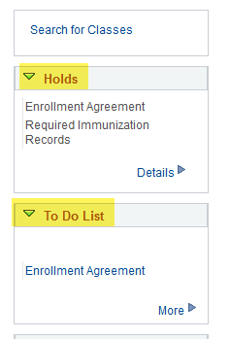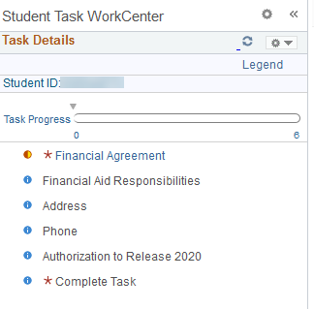

Read the Student Financial Agreement, select <Accept> and Save
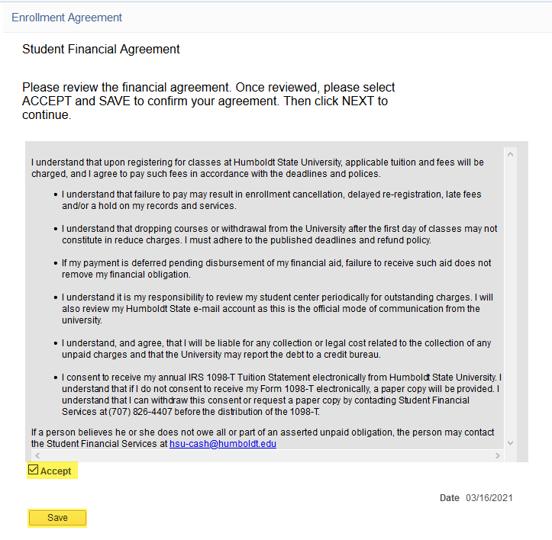

In the top right corner of the screen, select <Next> to proceed
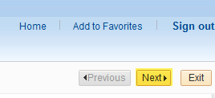

Read the Financial Aid Responsibilities, select <Accept> and Save
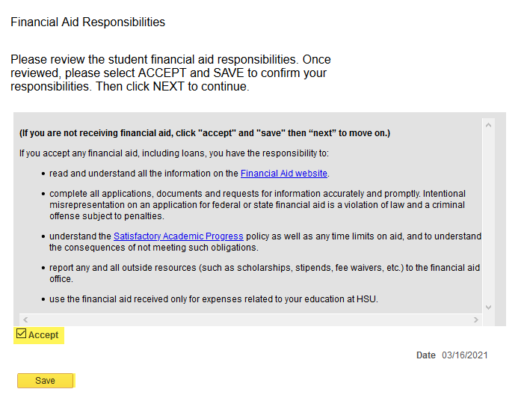

On the top right corner of the screen, select <Next> to proceed to the next screen

The student will also have the option of verifying their current address and make any updates. To update an address, select the <Edit> button.
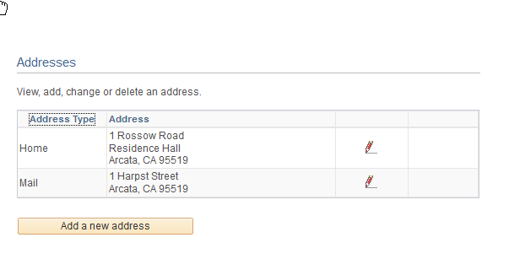

Update the information and then select <OK>
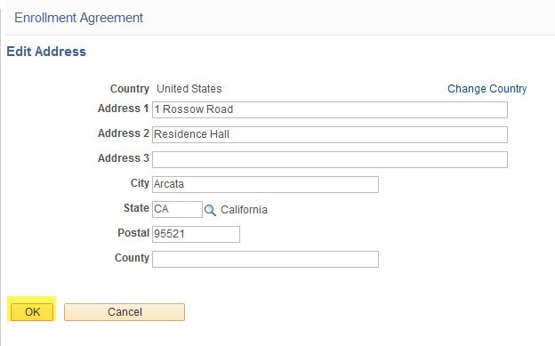
Select the <Save> button
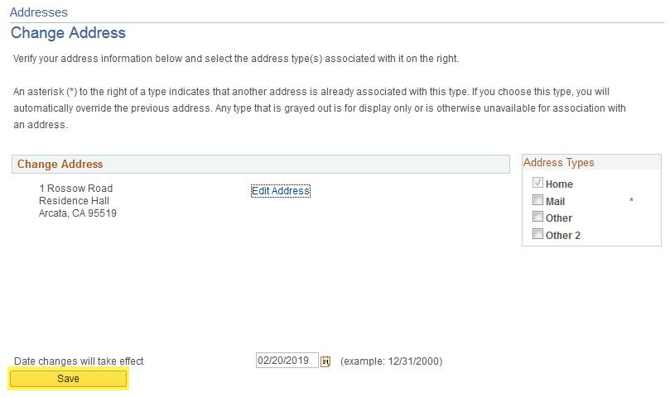
If the addresses are correct Select the “Mark As Complete” Button and then “Next”

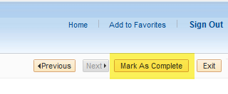
Select the <Next> button on the top right corner of the screen.
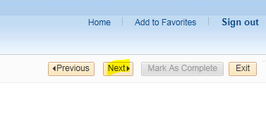
The student will also have the option of updating or verifying their current phone number. It is important to keep a current phone number so the University can reach you directly.
To update a phone, select the <Add a Phone Number> button.

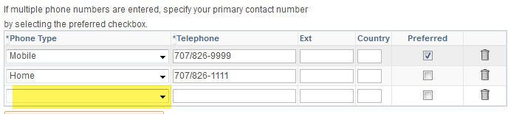
Enter the phone type and number

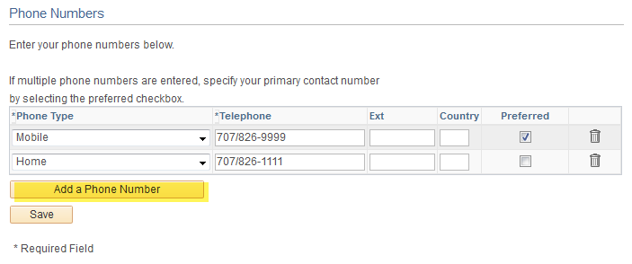

To delete a phone number, select the <Trash can> button
Select <SAVE>

Select <Mark Complete> and then select <Next>
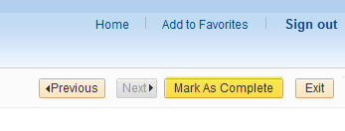

*New in spring 2021, additional options in the Authorization to release**
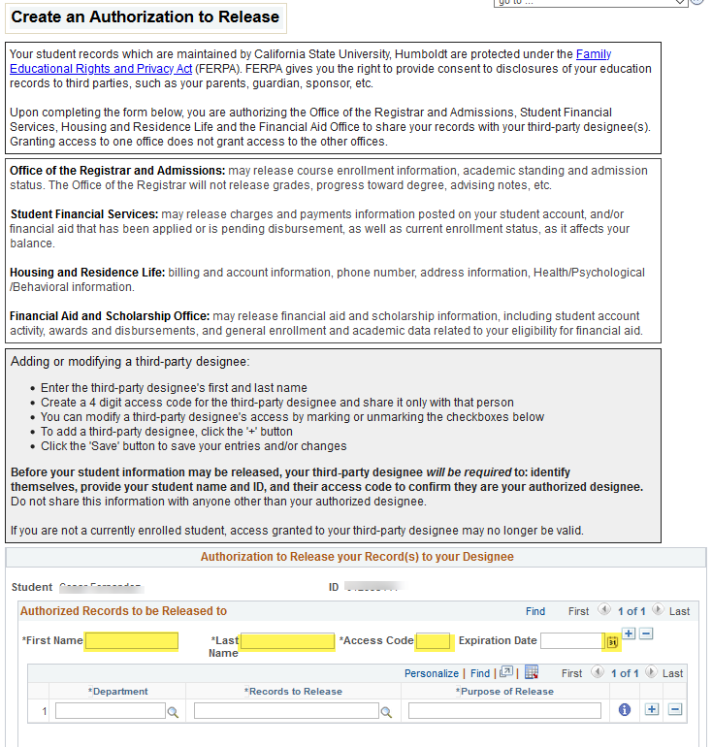

You can designate a person (parent, guardian, etc.) to who HSU can speak with regarding your student account and records. Each designee authorization will have an expiration date. You can allow their access for up to 1 calendar year.

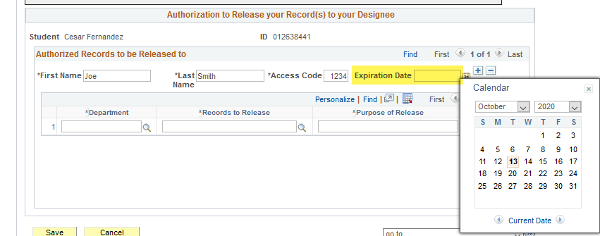

Select the Department from the drop down field. You can choose what information you would like your designee to have access to, just select by the department options.

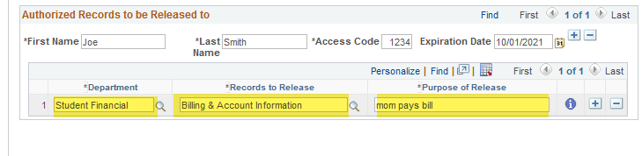

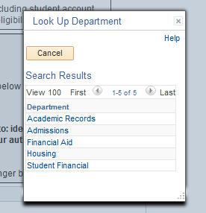

Select the Records to Be Release from the drop down menu. There are a few selections for each department

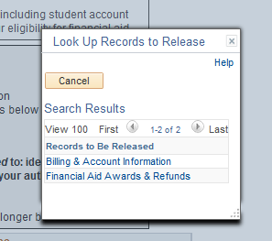

Enter a brief reason why you would like your records release to you designee. This is a free text field.

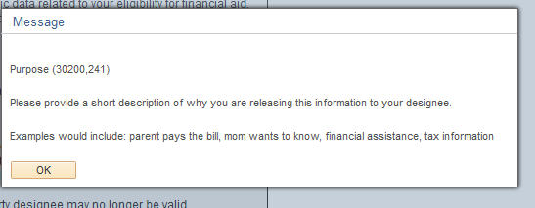

Select SAVE
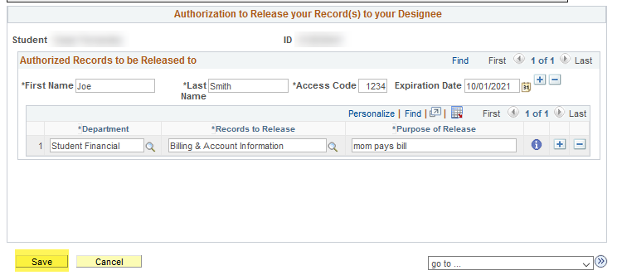

If you would like to add an additional designee, or remove a designee select the <+> or <-> sign on the highlighted area below.
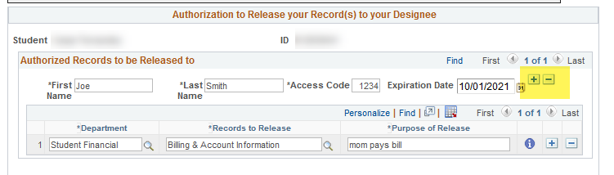

When done adding designees, select the next button on the top right corner
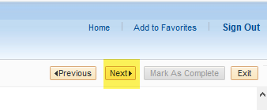

Click the Finish button to complete the task. The Student Task Work Center will keep track of where you are in the process

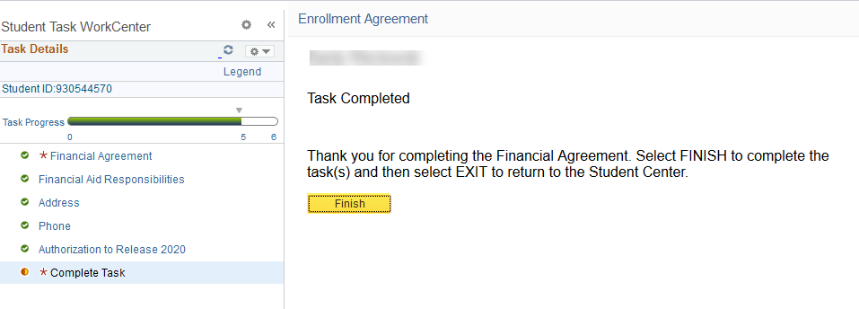

Once the agreement has been completed, the registration hold will immediately be taken off the student account.

