HSU Accounts Payables – Client Processes
All Humboldt invoices and payments will be processed through CSUBUY. For a quick overview of a typical CSUBUY invoice document, view Appendix A: CSUBUY Invoice Document.
The following details how a client would search, access, review and approve/reject the invoice document.

Searching and Accessing Payment
The following steps detail how HSU clients search using an Invoice Document Number or Supplier Invoice Number in CSUBUY.
- Login to CSUBUY via SSO.
- Utilize the Search (top right) to find the invoice and/or payment.
Note: Searching can be done via the Invoice Document Number of Supplier Invoice Number. The field will display the CSUBUY Invoice Document Number associated with it.
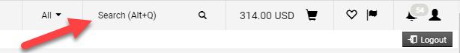
The follow steps detail how HSU clients search using other Invoice Document data points including the HSU Voucher Number.

- Login to CSUBUY via SSO.
- Navigate to Accounts Payables ()
  - Invoices
  - Search for Invoices
- Utilize the Quick Filters in the Search Invoices screen on the left side of the screen. Or, utilize available filters such as HSU Voucher Number with Add Filters.
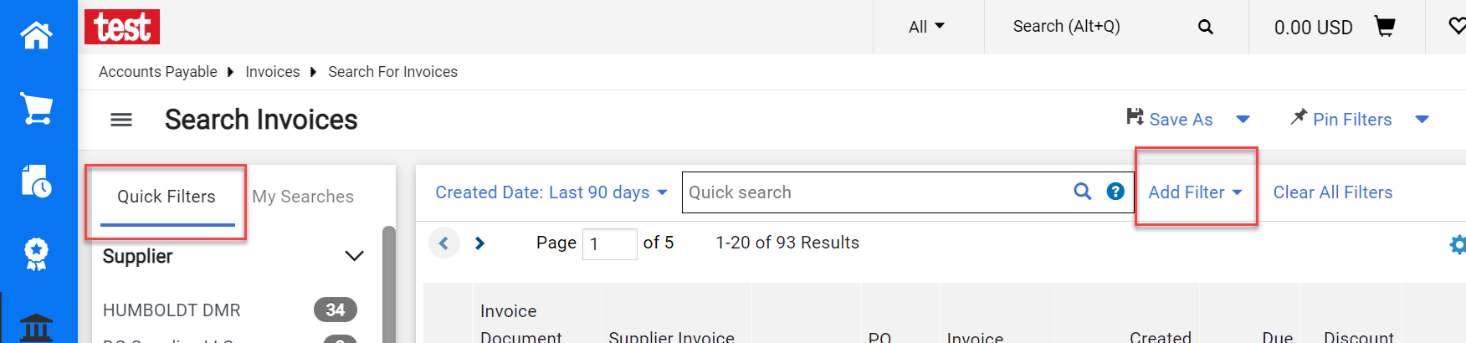

Access Assigned Invoice and/or Payments
The HSU AP team will assign Department Approvers invoice documents to review and approve/reject. There are three ways to access invoice documents assigned: CSUBUY Email, Notifications and via My invoices Approvals. The following are steps of how a Department Approver will access an invoice documents assigned. NOTE: the Search function above is also a method to find an invoice document.

Access Assigned Invoice via CSUBUY Email
HSU Department Approvers will receive a CSUBUY email indicating that an invoice has been assigned for approval. The following are the steps to access the invoice document from the CSUBUY email.
- Navigate to your email to find the CSUBUY email.
- Click on View Invoice in the email to access the invoice document.
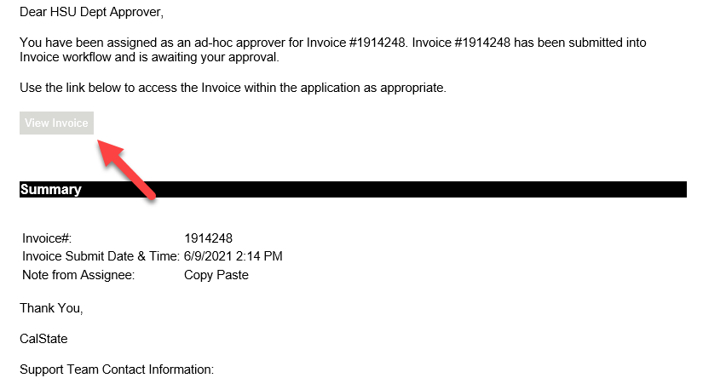

Access Assigned Invoice via Notifications
- Login to CSUBUY via SSO.
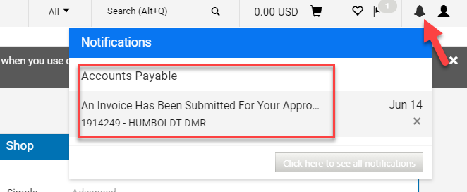
- Click on the Notification symbol on the top right next to your profile. It will indicate the number of notifications with a number bubble. When you click on the Notification symbol, a short list of Accounts Payable invoice document assigned will be displayed.
- Click on the notification to view the assigned invoice document or click on the bottom right button Click here to see all notifications.

Access Assigned Invoice via My Invoice Approvals
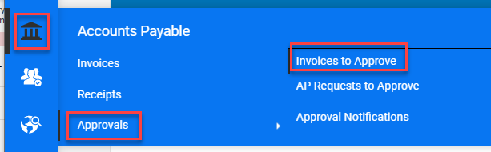
- Login to CSUBUY via SSO.
- Navigate to My Invoice Approvals to view a list of invoices assigned to be reviewed.
  - Accounts Payable (bank icon)
  - Approvals
  - Invoices to Approve

Review and Approving Payment
With the invoice document open, Department Approvers can review the details of the invoice and the digital copy of the invoice and/or payment request (Internal Attachments) to either approve, reject or assign another Department Approver. The following details the steps for Department Approvers.

Approving an Invoice Document
- Access and review the invoice document assigned. To view the digital copy of the invoice and/or payment request, navigate to the Internal Attachments section under Note/Attachments.
- Once it has been reviewed and deemed adequate to approve, navigate to the Pending section and click on Approve & Show Next. Note: if there is only one invoice document to approve, the icon will show Approve.
  - If there are more invoices to approve, CSUBUY will display the next invoice for review and approval.
  - If there are no more invoices to approve, it will display “No Documents Found” in your My Invoice Approval view.

Rejecting an Invoice Document
- Access and Review the Invoice Document Assigned. To view the digital copy of the invoice and/or payment request, navigate to the Internal Attachments section under Note/Attachments.
- Once it has been reviewed and deemed inadequate to approve, navigate to the Pending section and click on Reject.
- A new screen will appear to enter the reject reason for the invoice. Enter a detailed reject reason for the invoice.
- Click on Reject/Cancel.
  - If there are more invoices to approve, CSUBUY will display the next invoice for review and approval. If there
  - If there are no more invoices to approve, it will display “No Documents Found” in your My Invoice Approval view.
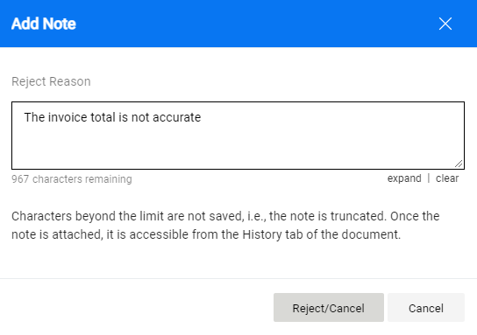

Assigning Another Department Approver
The following steps shows a Department Approver how to assign another approver to the invoice document.
- Navigate to the General section of the invoice document. At Ad-Hoc Approver, click Select.

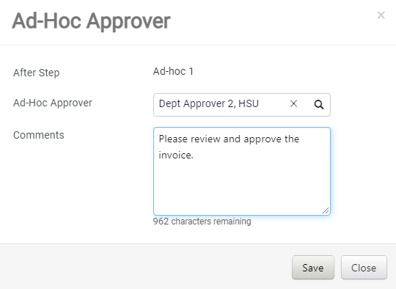
- The Ad-Hoc Approver screen will appear.
  - Type in the name of the new approver in the Ad-Hoc Approver field. Note: it is a smart field that will filter as you enter the name of the new approver.
  - Enter a note to the new approver in the Comments.
  - Click Save.
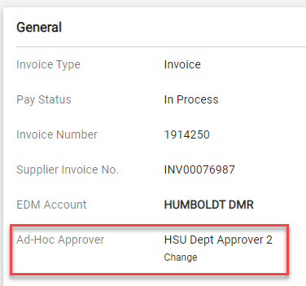
  - The new approver will appear in the Ad-Hoc Approver field in the General Section.

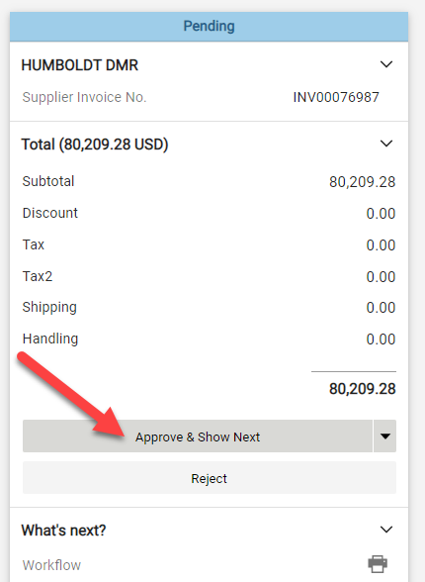
- Navigate to the Pending section and click on Approve & Show Next. Note: if there is only one invoice document to approve, the icon will show Approve.
  - If there are more invoices to approve, CSUBUY will display the next invoice for review and approval. If there
  - If there are no more invoices to approve, it will display “No Documents Found” in your My Invoice Approval view.

Appendix A: CSUBUY Invoice Document
Below is a sample of a CSUBUY invoice document. Key sections to be aware of are:
- Approve & Reject: actions approvers can take on the CSUBUY Invoice Document.
- General: includes general information about the invoice including the Supplier Invoice Number, Invoice Date, Due Date and Ad-Hoc Approver.
- Note/Attachments: the Internal Attachment sections includes the digital copy of the supplier invoice and/or payment request.
- Status: the current status of the Invoice Document and the amount of the payment.
- Line: details for the line items of the invoice and/or payment
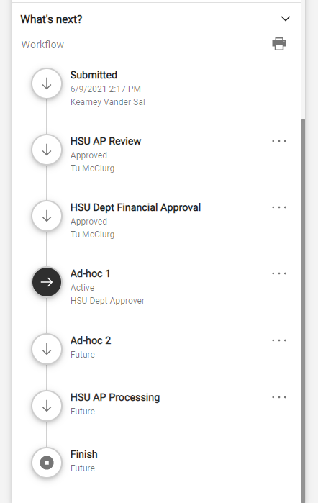
- What’s Next: the workflow view for the invoice document.
