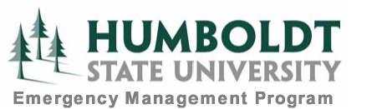

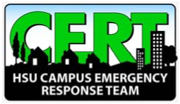

Campus Emergency Response Team (CERT)
Participant Application Form

The HSU Campus Emergency Response Team is a self-contained, multi-purpose unit comprised of trained volunteer staff, faculty and students from many different departments and divisions. When a major campus event occurs, HSU will activate the CERT team and assign duties appropriate to the event. The tasks assigned include the following:
- Executing light search and rescue; extrication of trapped persons
- Providing medical first aid and triage of the injured
- Preventing and suppressing small fires
- Supporting other emergency field operations
CERT members attend a 20 hour training academy utilizing FEMA curriculum. After completing the CERT academy, members are expected to attend monthly meetings, take part in refresher events and mobilize as available during any HSU activations. Disaster drills also provide an opportunity to refine skills and integrate CERT into campus emergency functions. All safety equipment is provided.
CERT Applicant Information
Name: |  |  | Circle One: Staff Faculty Student
Staff/Faculty Only: | Position: |  | Office Location: | Ext:
Home Address:
Home Phone: |  | Cell Phone: | Email
List any specialized skills:

Statement of interest (describe why you are interested in being a part of HSU CERT):

Signature:__________________________________

Department Authorization for Staff/Faculty
I hereby authorize this employee to be an active CERT participant, understanding that release time will be necessary for training and activation purposes.
Department Chair/Manager/Director | Signature | Date
Submit to Willie Bence, Emergency Management Coordinator SBS 311 or at wb378@humboldt.edu

