Requesting Access for Approving Delegation of Authority for Users Currently **Without** Delegation of Authority Approval

|  |
| --- |
| *If the user does not currently have DOA Approval access, it requires two parts:*   * ***Part one:*** *Request Role*   *AND*   * ***Part 2:*** *Sign Agreement sent to you via email* |

**Part One - Request Role:**

From the MyHumboldt portal click on Account Settings under Tools:

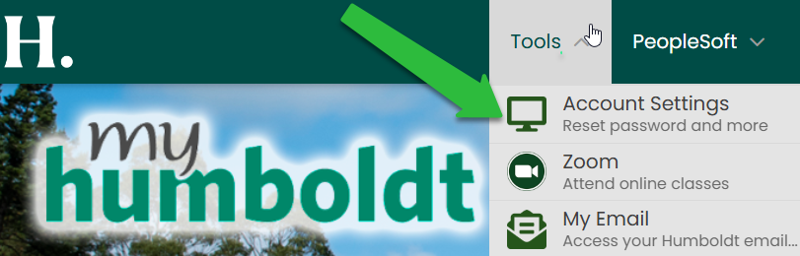

Click on Requests (see green arrow) and then the REQUEST ACCESS tab:



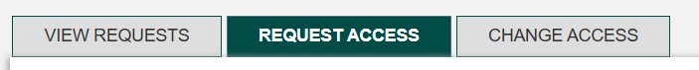

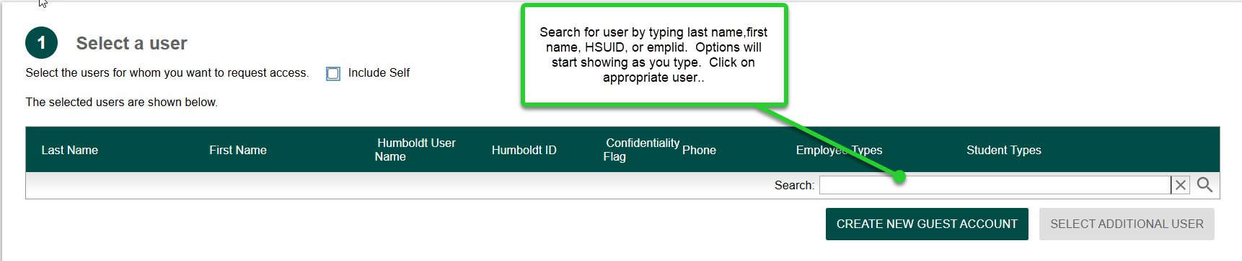On the next screen that appears enter user information:

In the Filter Roles by drop down box select Search



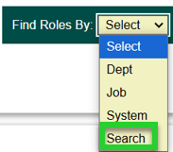



Enter ***Delegation of Authority Approver*** in Name box and click on search arrow.

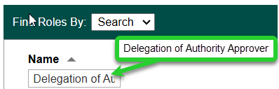

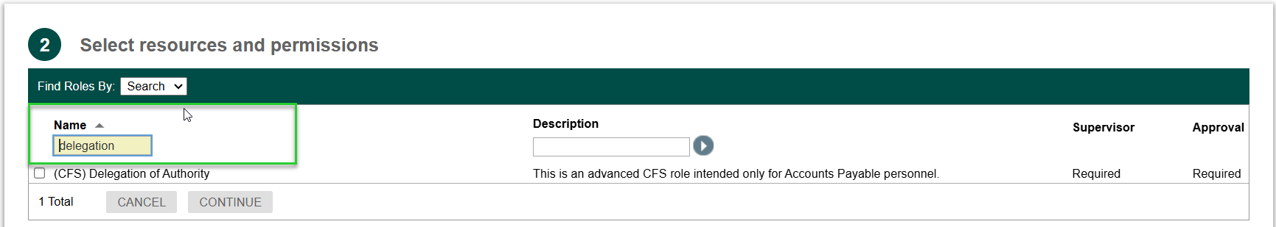



Select (CFS) **Delegation of Authority Approver** option by clicking check box. Then click the CONTINUE button.

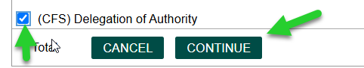



Select supervisor by clicking on the person icon

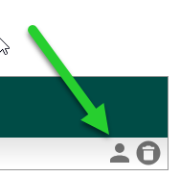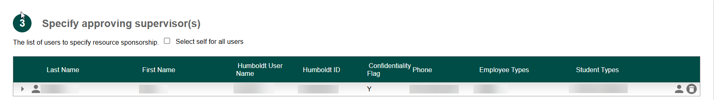

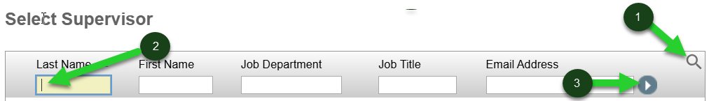Click on spy glass, enter last name of supervisor, and click the search arrow.

Click the Continue button.



Select access period, enter comments, and Submit request.





**Part Two – Sign Agreement sent to you via email:**

When part one is complete an email will be sent requesting the DOA Approver’s signature via Adobe Sign agreeing to terms of being a DOA Approver.