Dr. Amy Sprowles
Humboldt State University

From Chickens to Hippos to Zombies: Defining the role of JNK signaling in Development, Death and Cancer
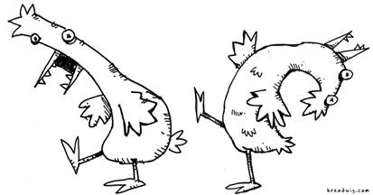

Research Seminar:
Thursday Feb. 13th, 5pm in Siemens Hall 108

Teaching Presentation:
Friday Feb. 14th, noon in Natural Resources 101

Differential Gene Expression in Development

Dr. Sprowles is a candidate for a new faculty position in the Department of Biology, specializing in Cell and Developmental Biology.

For further information please contact Mark Wilson: email (msw13) or 826-5557

